AGGRESSION DETECTION

Emotions are what people feel. They are caused by a complex mixture of hormones and the unconscious mind trying to adjust to the environment. Only with great difficulty do human beings control their emotions by conscious effort. Emotions cause mammals to change behavior according to changes in their situation. In human being’s case they sometimes run against our attempt to live our lives in a logical way.[1]

A scientific definition is not simple; over 90 definitions have been offered by experts. A definition of emotion needs to include three things:
- Conscious experience (feelings)
- Expressions which can be seen by others
- Actions of the body ('physiological arousal')

Here is one definition:
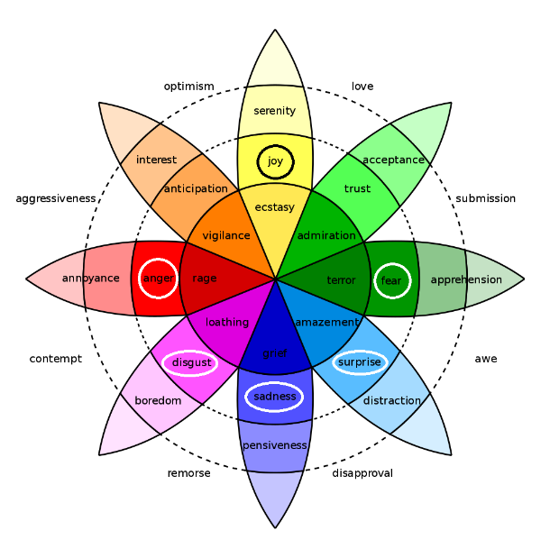
"Emotion is a complex psychological phenomenon which occurs as animals or people live their lives. Emotions involve physiological arousal, appraisal of the situation, expressive behaviors, and conscious experience. Emotion is associated with feeling, mood, temperament, personality, disposition, and motivation".
Now Human beings with evolution have learnt a humongous range of emotions like Affection, Anger ,Angst ,Anguish, Annoyance, Anticipation ,Anxiety, Apathy, Arousal, Awe, Boredom, Confidence ,Contempt ,Contentment, Courage ,Curiosity, Depression, Desire ,Despair ,Disappointment, Disgust, Distrust, Ecstasy ,Embarrassment, Empathy, Envy, Euphoria, Fear ,Frustration ,Gratitude, Grief, Guilt, Happiness, Hatred, Hope ,Horror, Hostility, Humiliation, Interest, Jealousy, Joy ,Loneliness ,Love, Lust ,Outrage, Panic, Passion, Pity Pleasure, Pride ,Rage, Regret, Remorse ,Resentment ,Sadness ,Schadenfreude, Self-confidence, Shame, Shock, Shyness, Sorrow, Suffering, Surprise, Trust, Wonder, Worry.

But the ones that are basic to all the above emotions are Anger, Disgust, Fear, Joy, Sadness and Surprise.
If human beings come under duress they immediately switch back to their basic emotional spectrum.
Anger and Aggression in human Beings stand out a lot because of their negative nature. Affecting nearby human beings, aggression just might be the most researched emotion. Controlling aggression, holding workshops on anger management, human beings have tried a lot to detect aggression and control it.
Aggression detection in patients ,especially those suffering from degenerative neurological diseases is one of the most wanted technologies.
Aggression can take many forms like:
- Physical eg. hitting, pinching, scratching, hair-pulling, biting.
- Verbal eg. swearing, screaming, shouting, making threats
- Emotional and Mental
While we often think of aggression as purely in physical forms such as hitting or pushing, psychological aggression can also be very damaging.
Purposes of Aggression
- Expressing anger or hostility
- Asserting dominance
- Intimidatuin
- Expressing or mark terrritory
- Natural response or reflex to fear
- Reflex to pain received
- Competition

Types of Aggression
Aggression can be classified into mainly two different types
1. Impulsive Aggression
Impulsive aggression, also known as affective aggression, is characterized by strong emotions, usually anger. Happening as a heat of the moment emotion, these are usually unplanned. When another car cuts you off in traffic and you begin yelling and berating the other driver, you are experiencing impulsive aggression.
2. Instrumental Aggression
Instrumental aggression, also known as predatory aggression, is marked by behaviors that are intended to achieve a larger goal.These type is usually well planned to get a particular goal. Hurting another person in a robbery or car-jacking is an example of this type of aggression.

When aggression in adults is not a response to a clear threat, it is sometimes considered a sign of mental disorder. In fact, there is a scientific nexus between aggression and mental illness, with many mental disorders such as schizophrenia ,alcoholism and dementia also manifesting aggressive behavior. Aggression may be directed outward against others, causing damage, as in the case of explosive personality disorders.
The concept of aggression is used in many different contexts. Importantly, it has been applied to animal behavior as well as human behavior. It is used to describe personality and attitudes, as well as to characterize behavior in both children and adults. When aggression is used in the medical field, it often linked to a mental disorder, such as epilepsy.

The significance of aggression for the nursing profession cannot be overemphasized. It links person, environment, health/illness, and health outcome. Specially, physical aggression can result in violence and injury. Nurses in the hospital emergency unit face the consequences of negative aggression every day. Nurses are physically assaulted, threatened, and verbally abused more often than other professionals .
Nursing interventions early in life have been shown to reduce rates of aggression in teenagers (Olds et al., 1998). If these findings could be replicated, the nursing profession could play a major and significant role in reducing rates of aggressive criminal acts in society. For every 1% of aggressive violent acts perpetrated in society, the cost to USA has previously been estimated at $1.5 billion (Resis & Roth, 1993) and is clearly greater today. This represents money that could be better spent on providing increasing health care to underserved populations.

AIM:-
The aim of this analysis is to detect aggression before hand in patients before they turn aggressive towards other patients and their caregivers.(especially in Patients with Dementia and degenerative Neurological diseases).
Causes of aggressive behavior in Patients with Dementia[3]
People with dementia have the same needs as everyone else, including comfort, social interaction, stimulation, emotional wellbeing and being free from pain.However due to their degenerative disorders their social skills take a blow and they are usually unable to express this to other people.Thus making them lash out and cause them to act in ways that others might find challenging, including aggression.

The aggressive behavior might be the person's way of meeting the need, an attempt to communicate it, or an outcome of the unmet need.
For example, if a person with dementia is not getting enough stimulation they might become bored, and this may lead to them behaving in a way that others might find challenging, such as walking about or following their caregiver. Meeting the need by providing stimulation to the person may stop the behavior as they will no longer be bored.
Understanding what is causing the person's behavior can help caregivers to find a solution.
Some Major reasons of Aggressions are listed.
Biological
- Untreated illnesses (like infections) and physical pains like dehydration or discomfort because of being stationary in a single place.
- Side effects and/or taking too many medications may mean that a person becomes more confused and drowsy. This means they may be less able to problem-solve their way out of distressing situations.
- The environment not being conducive enough to meet their standards,both under and over exposure will lead to aggression.
- Hallucinations due to side effects can also cause aggression.
- The physical effects of dementia may have affected the person's judgment and self-control. They may have lost their inhibitions or have a decreased awareness of what kind of behavior is appropriate.
Social
- Lack of social contact and loneliness.
- Boredom, inactivity and sensory deprivation.
- Different caregivers coming in with a different approach or changing the established routine.
- Not liking or trusting a particular caregivers.
- Trying to hide their condition from others.
Psychological
- The person with dementia may have a perception that their rights are being infringed or that they are being ignored.
- The person may become frustrated at not being able to complete tasks, example like making a cup of tea.
- There may be depression or other mental health problems.
- A caregiver’s intentions may be misunderstood. For example, personal care may be seen as threatening or an invasion of personal space. Accepting help with intimate tasks such as washing, dressing or going to the toilet is understandably distressing and stressful.
- Others may assume that the person with dementia can no longer do things for themselves or leave them out of decisions that affect them. This can cause the person with dementia to become angry because they are not being listened to or are being ignored.
- People may have difficulties understanding and interpreting the world around them, and may experience a different sense of reality from others. For example, if the person believes that they need to collect their children from school, they may become aggressive if they are prevented from doing so.
What is Dementia ?

Dementia is a broad category of degenerative brain diseases that cause a long term and often gradual decrease in the ability to think and remember that is great enough to affect a person's daily functioning.

Other common symptoms include emotional problems, problems with language, and a decrease in motivation.A person’s moral consciousness is usually not affected. A dementia diagnosis requires a change from a person's usual mental functioning and a greater decline than one would expect due to aging.These diseases also have a significant effect on a person's caregivers.

The most common type of dementia is Alzheimer's disease, which makes up 50% to 70% of cases. Other common types include vascular dementia (25%), Lewy body dementia (15%), and frontotemporal dementia.

What is Alzheimer’s?

Alzheimer's is a type of dementia that causes problems with memory, thinking and behavior. Symptoms usually develop slowly and get worse over time, becoming severe enough to interfere with daily tasks.

Alzheimer's is the most common form of dementia, a general term for memory loss and other cognitive abilities serious enough to interfere with daily life. Alzheimer's disease accounts for 60 to 80 percent of dementia cases.

Signs and symptoms of dementia

The symptoms of dementia vary across types and stages of the diagnosis.
The most common affected areas include memory, visual-spatial, language, attention and problem solving.
Most types of dementia are slow and progressive.
By the time the person shows signs of the disorder, the process in the brain has been happening for a long time.
Additional psychological and behavioral problems that often affect people who have dementia include:
- Balance problems
- Tremor
- Speech and language difficulty
- Trouble eating or swallowing
- Memory distortions (believing that a memory has already happened when it has not, thinking an old memory is a new one, combining two memories, or confusing the people in a memory)
- Wandering or restlessness
- Perception and visual problems
- Behavioral and psychological symptoms of dementia (BPSD) almost always occur in all types of dementia. BPSDs may manifest as:
- Agitation
- Depression
- Anxiety
- Abnormal motor behavior
- Elated mood
- Irritability and Apathy

Technology and mathematical models required
- Bayesian Network
- Dynamic Bayesian Network
- MANET
What are Bayesian Networks?
A Bayesian network, Bayes network, belief network, Bayesian model or probabilistic directed acyclic graphical model is a probabilistic graphical model (a type of statistical model) that represents a set of random variables and their conditional dependencies via a directed acyclic graph (DAG). For example, a Bayesian network could represent the probabilistic relationships between diseases and symptoms. Given symptoms, the network can be used to compute the probabilities of the presence of various diseases.
Formally, Bayesian networks are DAGs whose nodes represent random variables in the Bayesian sense: they may be observable quantities, latent variables, unknown parameters or hypotheses. Edges represent conditional dependencies; nodes that are not connected (there is no path from one of the variables to the other in the Bayesian network) represent variables that are conditionally independent of each other. Each node is associated with a probability function that takes, as input, a particular set of values for the node's parent variables, and gives (as output) the probability (or probability distribution, if applicable) of the variable represented by the node. For example, if m parent nodes represent m Boolean variables then the probability function could be represented by a table of 2 ^{m} entries, one entry for each of the 2 ^{m} possible combinations of its parents being true or false. Similar ideas may be applied to undirected, and possibly cyclic, graphs; such as Markov networks.
Efficient algorithms exist that perform inference and learning in Bayesian networks. Bayesian networks that model sequences of variables (e.g. speech signals or protein sequences) are called dynamic Bayesian networks. Generalizations of Bayesian networks that can represent and solve decision problems under uncertainty are called influence diagrams.

What are Dynamic Bayesian Networks?
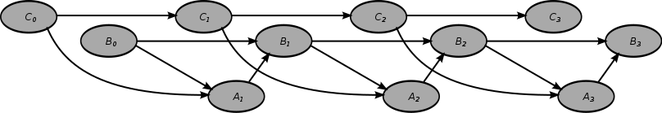
Dynamic Bayesian Network (DBN) is a Bayesian network which relates variables to each other over adjacent time steps. This is often called a Two-Timeslice BN (2TBN) because it says that at any point in time T, the value of a variable can be calculated from the internal regressors and the immediate prior value (time T-1). DBNs were developed by Paul Dagum in the early 1990s when he led research funded by two National Science Foundation grants at Stanford University's Section on Medical Informatics.Dagum developed DBNs to unify and extend traditional linear state-space models such as Kalman filters, linear and normal forecasting models such as ARMA and simple dependency models such as hidden Markov models into a general probabilistic representation and inference mechanism for arbitrary nonlinear and non-normal time-dependent domains.
Today, DBNs are common in robotics, and have shown potential for a wide range of data mining applications. For example, they have been used in speech recognition, digital forensics, protein sequencing, and bioinformatics. DBN is a generalization of hidden Markov models and Kalman filters.

SOLUTION
The entire subject of this report is to address the issue of the detection of aggression in the nursing field.
Patients with degenerative neurological diseases tend to be more aggressive towards other patients and their own caregivers.

The solution is to provide a smart surveillance system that identifies the patients that tend to have aggressive traits ,constantly monitors them and warns others before hand of an impending aggression before hand by using
- Dynamic Bayesian Networks in it’s Visual Feature extraction part,
- Using sudden changes in the pitch ,note and voice(called the Lombard Reflex ,the involuntary tendency of speakers to increase their vocal effort when speaking in loud noise to enhance the audibility of their voice)
- Fusing multi-modal data streams:-Combining both the audio and visual data to create an approximate model to detect aggression.

Previous Works
1. Multi-modal human aggression detection [2] J.F.P.Kooija,M.C.Liema,J.D.Krijndersb,1,T.C.Andringab,D.M.Gavrilaa,
According to the prevalent definition,“aggression is any form of behavior directed toward the goal of harming or injuring another liv-ing being who is motivated to avoid such treatment”.As human aggression is an active field of study in psychology and other social sciences,several attempts have been made to quantify aggression.Most rating scales consist ofself-report questionnaires,which ask people about their own experiences and feelings of aggression(e.g.“I some times feel very angry”).One of the few to involve observable behavior is the Overt AggressionScale (OAS).OAS divides violent behavior in four categories:
1)verbal aggression
2)physical aggression against objects
3)physical aggression against self and
4)physical aggression against other people Aggressive behavior is rated within each category ,guided by some representative examples. Still,rating remains subjective in parts and difficult to assess from direct observations (e.g.distinguishing between minor versus serious injuries).

This Paper by J.F.P.Kooij, M.C.Liem, J.D.Krijnders, ,T.C.Andringa, and D.M.Gavrila creates a smart surveillance system that detects aggression in a group of people.This model uses DBN,Lombard reflex and other algorithms and combines them to create a model that detects aggression in humans even in noisy environments.
2. Audio-Visual Fusion for Detecting Violent Scenes in Videos
Theodoros Giannakopoulos, Alexandros Makris, Dimitrios Kosmopoulos,Stavros Perantonis, and Sergios Theodoridis
This research towards the detection of violent scenes in movies, employing fusion methodologies, based on learning.
3. Objects in Action: An Approach for Combining Action Understanding and Object Perception
Abhinav Gupta and Larry S. Davis
Analysis of videos of human-object interactions involves understanding human movements, locating and recognizing objects and observing the effects of human movements
on those objects. While each of these can be conducted independently, recognition improves when interactions between these elements are considered. Motivated by psychological studies of human perception, we present a Bayesian approach which unifies the inference processes involved in object classification and localization, action understanding and perception of object reaction.

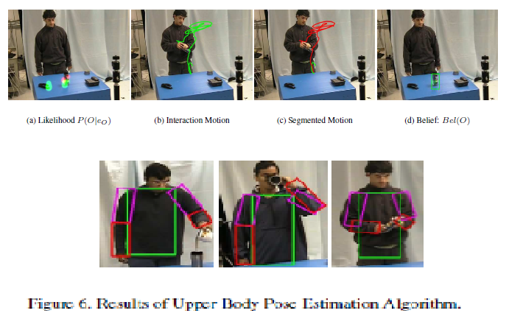
4. Multicamera People Tracking with a Probabilistic Occupancy Map
Franc¸ois Fleuret, Je´ roˆme Berclaz, Richard Lengagne, and Pascal Fua, Senior Member, IEEE
Given two to four synchronized video streams taken at eye level and from different angles, we show that we can effectively combine a generative model with dynamic programming to accurately follow up to six individuals across thousands of frames in spite of significant occlusions and lighting changes. In addition, we also derive metrically accurate trajectories for each of them. Our contribution is twofold. First, we demonstrate that our generative model can effectively handle occlusions in each time frame independently, even when the only data available comes from the output of a simple background subtraction algorithm and when the number of individuals is unknown a priori. Second, we show that multiperson tracking can be reliably achieved by processing individual trajectories separately over long sequences, provided that a reasonable heuristic is used to rank these individuals and that we avoid confusing them with one another.
Tracking multi people
5. Person-on-Person Violence Detection in Video Data
Ankur Datta Mubarak Shah Niels Da Vitoria Lobo
We address the problem of detecting human violence in video, such as fistfighting. kicking, hitting with objects.To detect violence we rely on motion trajectory. Information and on orientation information of a person’s limbs. We define an Acceleration Measure Vector (AMV) composed of direction and magnitude of motion and we define jerk to be the temporal derivative of AMV.
We present results from several data sequences involving multiple types of violent activities
SOLUTIONS TO DETECT AGGRESSION
Understanding the Triggers
Alzheimer’s aggression can flare up without warning. There may not be an obvious cause. But many times, there are triggers you can spot before or during a problem. Common ones include:
- Discomfort from lack of sleep, side effects from medication, or pain that she can’t describe
- The environment around her, including loud noises, too much activity, or clutter
- Confusion from being asked too many questions at once, trying to understand complex instructions, or feeling the stress of caregivers
The solution to detecting aggression is to address all the triggers of aggression in dementia patients.
Wearable solutions
1.Lack of sleep-Can be tracked using Wearable.
2.Elevated levels of heart rate :- Can be tracked using wearable.
3.Breathing Patterns:- Gadgets like Spire monitor breathing to gauge stress levels
4.Audio Fluctuations:- Sudden shouting or taunts can be monitored using wearable.This uses Lombard Reflex.
5.Pacing up and down:- Wearable with pedometer facility can calculate if the person is pacing or working out if the location isn’t changing with respect to the number of steps taken.
6.Wearable can also be fitted with extra sensors to detect electrical signals from the skin,like perspiration rate with respect to breath rate and heart rate to calculate pre aggression level.
The above triggers can be put together in one app on a wearable to give a solid reading about patient aggression probability.
Patient on Patient Aggression
Wearable with the help of Bluetooth,Wifi or any near field communication protocols can communicate with other wearables.So suppose one patient is near another patient,the wearable of both(or more wearable) connect and send a signal if both wearable detect elevated levels of aggression.
Patient on Caregiver Aggression
Wearable with the help of Bluetooth,Wifi or any near field communication protocols can communicate with other wearables.So suppose one patient is near a caregiver ,the wearable of both(or more wearable) connect and send a signal if both wearable detect elevated levels of aggression.
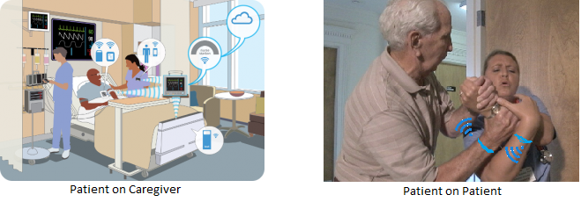

Both the patient on patient and patient on caregiver can be connected via a single WiFi network or they can connect with a MANET protocol.

CITATIONS
[1] Robert Plutchik 2001. The nature of emotions. American Scientist

[2]Multi-modal human aggression detection
J.F.P.Kooij, M.C.Liem, J.D.Krijnders, ,T.C.Andringa, and D.M.Gavrila,
[3]http://www.alz.org/alzheimers_disease_what_is_alzheimers.asp
[4] Audio-Visual Fusion for Detecting Violent Scenes in Videos
Theodoros Giannakopoulos, Alexandros Makris, Dimitrios Kosmopoulos,
Stavros Perantonis, and Sergios Theodoridis
[5]A survey on vision-based human action recognition
Ronald Poppe
[6] Multicamera People Tracking with a Probabilistic Occupancy Map
Franc¸ois Fleuret, Je´ roˆme Berclaz, Richard Lengagne, and Pascal Fua, Senior Member, IEEE
[7] Person-on-Person Violence Detection in Video Data
Ankur Datta Mubarak Shah Niels Da Vitoria Lobo
Behar, D.; Hunt, J.; Ricciuti, A.; Stoff, D.; Vitiello, B. (1990). Subtyping Aggression in Children and Adolescents. The Journal of Neuropsychiatry and Clinical Neurosciences 2 (2): 189–192.

Berkowitz, L. (1993). Aggression: Its causes, consequences, and control. New York, NY: McGraw-Hill.
(Brennan, Mednick, & Hodgins, 2000; Hodgins & Grunau, 1988; Shelton, 2001)
(Citrome & Volavka, 2001; Pihl & Peterson, 1993)
(Carlsson, Dahlberg, Lutzen, & Nystrom, 2004; Gates, Fitzwater, & Succop, 2003).

